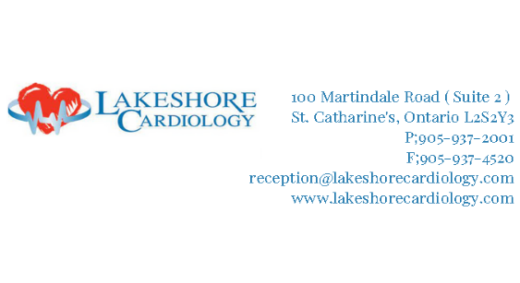

*CCPA*
Lakeshore Cardiology is a community-based Heart Health Wellness Clinic.
The PA will provide a full range of physician assistant services in accordance with privileges granted, request consultation or referral with appropriate physicians, clinics, or other health care resources as indicated, order diagnostic tests as applicable, prescribe and dispense medications, and triage clinic referrals.
VALUES:
- Patient centered focus for planning and quality of life
- Supportive, inclusive, multidisciplinary team approach to Specialty Medicine
- Respect for all roles in the multidisciplinary team, and tolerance of our differences
- Open and clear communication among all team members
- Recognition of and respect for all team members’ private lives
QUALIFICATION:
- Graduate of an accredited Physician Assistant program
- Canadian Certified Physician Assistant (CCPA)
- Performing comprehensive and problem-focused histories, physical examinations, patient screening, and appropriate laboratory and diagnostic studies
- Exhibit the ability to work alongside Physicians, Nurses, and other Health Care Professionals
- Display excellent interpersonal and communication skills
- Ability to promote professional development
- Exhibit excellence in leadership and critical thinking skills
- Exemplify commitment to patient and family-centered care
- Demonstrate the ability for independent action, initiative, problem-solving, organization and prioritization
- Co-develop patient care plans with Physicians
- Facilitate application of clinical protocols
- Request consultation or referral with appropriate physicians, clinics or other health care resources as indicated
- Order diagnostic tests as deemed necessary
- Prescribe and dispense medications as in accordance with *CCPA guidelines
- Commitment to attend work on a regular basis
- Diligent in data entry
- BLS/ACLS up to date
BENEFITS:
- Health Benefit Package
- Dental
- CME/CPD compensation *offer discussed at contract*
- Parking on site
- Weekly lunches
- Day shifts
- Competitive salary
Lakeshore Cardiology policy requires as approved by Health Canada that all staff have received all required doses as per COVID-19. As part of our dedication to the health and safety of our patients, staff, and the Heart Health Community from COVID-19, subject to any arrangement required by applicable human rights legislation.

Thank you in advance for your interest in Lakeshore Cardiology.
If you would please forward your CV with cover letter as to your interest in the C.C.P.A position at our Clinic.

